**Problem Set 3**

**Impact Evaluation for Social Programs**

January 2021

Due: January 22nd 2021, send to **charlotte.robert@awi.uni-heidelberg.de**

**Required reading**: *Card, David & Krueger, Alan B, 1994. "Minimum Wages and Employment: A Case Study of the Fast-Food Industry in New Jersey and Pennsylvania," American Economic Review, American Economic Association, vol. 84(4), pages 772-793, September. Can be found here:* [*https://ideas.repec.org/a/aea/aecrev/v84y1994i4p772-93.html*](https://ideas.repec.org/a/aea/aecrev/v84y1994i4p772-93.html)

The problem set will be graded out of 20 and the final grade is then standardized to be out of 10. Each group member receives the same grade.

This is a group work: groups should be of 2-3 people. If you do not have a partner or face problems within your group, please email me and we will find a solution.

**Note that it is highly recommended that every member in the group has read the paper, as it is a mandatory reading for the exam.**

Answer the Overview questions (Part 1) on your dofile. Results should be presented into clean tables when required, made by exporting tables from Stata either to Excel or LaTeX (0.5 bonus point if made with LaTeX). The code to make the tables should also be included. If you do not manage to export your results via Stata, you should create a table manually so that your results can still be read.

Figures and tables should then be presented and commented in a unique PDF file, with captions, title and variable names used in the original paper. In particular, one should be able to take a look at an individual table and know exactly what’s being done in your results without reading anything else you’ve done.

**Important**: Anything that is not code should be commented in your dofile, using either * or //! The code should run smoothly from start to finish. The names of all group members should be on the dofile.

Answers should be submitted **once** per group, adding the other members of your group in CC. All names should also figure on both your PDF and your dofile. PDF and dofile should be named “PS3_insert_last_names”. The problem set is due January 22nd at 23:59.

Grading grid:

|  |  |  |  |
| --- | --- | --- | --- |
| Part 1 | | Part 2 | |
| Q1 | 1pt | **Q1** | 0.5pt |
| Q2 | 1pt | **Q2** | 0.5pt |
| Q3 | 2pt | **Q3** | 2pt |
| Q4 | 2pt | **Q4** | 2pt |
| Q5 | 2pt | **Q5** | 2pt |
|  |  | **Q6** | 1pt |
|  |  | **Q7** | 1pt |
|  |  | **Q8** | 1pt |
|  |  | **Q9** | 2pt |
| Total | 8pt | **Total** | 12pt |

**Part 1** – Overview questions. Report the question number, question content and number of points in your dofile.

Q1: What is the causal link the paper is trying to reveal? What is the motivation for the paper and the research question(s) the authors try to answer? What are the main results and how does it compare to what conventional economic theory suggests? (1pt)

Q2: What would be the ideal experiment to test the causal effect that the authors want to reveal? What is the identification strategy of the authors instead? (1pt)

Q3: What assumption(s) do the authors make when using this identification strategy? Give two potential threats to their identification strategy, precising the direction in which it could bias the estimation of the effect (downward or upward). (2pt)

Q4: In response to this criticism of their research, Card and Krueger published a reply in the AER 2000, in which this figure was presented:

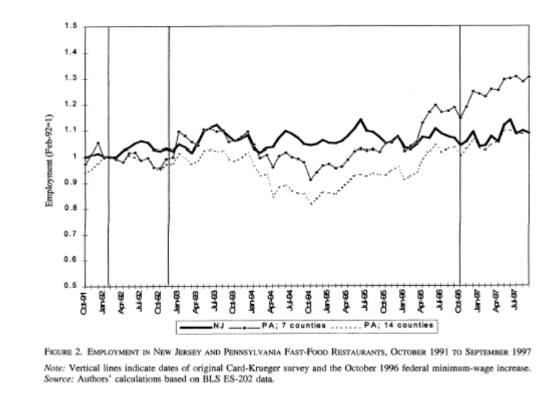

The first vertical line show the implementation of the minimum wage rise in New Jersey that they studied in their initial paper, the second vertical line a further rise and the final vertical line a rise in the federal minimum wage which harmonized the minimum wages between New Jersey and Pennsylvania. The lines represent employment in fast-food restaurants in NJ and two selections of PA counties.

What criticism did the authors address with this figure? Interpret what is shown. (2pt)

Q5: In your opinion, what are the major critical points of the paper? Explain the main weaknesses (at least three are expected) and how it threatens their analysis. (2pt)

**Part 2 – Replication**

The data used by the authors can be found in the dataset “cardkrueger94.dta”. The description of the data can be found in the pdf “cardkrueger94_description.pdf”. Results may vary from original study since the data has been simplified.

1. Label the variables using the labels given in the pdf.
2. Plot the Kernel Density of Wages in New Jersey and Pennsylvania before and after the change in the law, the kernel density of Employment and Employment Changes in New Jersey and Pennsylvania. You should have one figure with all four plotted densities and a legend. Export the figure and add it to your final pdf file with a title, caption and an interpretation.
3. Reproduce the results presented in Table 1 (page 774). Export your table to Excel or LaTeX and add it to your final pdf file with a title, caption and an interpretation of the table. What is the purpose of such table? What can you say?
4. Reproduce Table 2 (p.776), presenting differences in mean results in the last columns, reporting p-value in parenthesis and highlighting significant differences with stars (*** at 1% level, ** at 5% and * at 10%). Export your table to Excel or LaTeX and add it to your final pdf file with caption and interpretation of the table. What is the purpose of such table? What can you say?
5. Reproduce figure 1. Export it and add it to your final pdf file with title, caption and comment. What do the authors show with such a graph?
6. Use mean differences to compute the difference in means estimate of the variation in minimum wage between the control group and the treatment group.
7. Estimate the differences-in-differences using a simple OLS regression model where the left-hand-side variable is **the variation in the outcome of interest**. Run a first regression, then a second adding the robust option. What happens to the standard errors when adding robust? What can we say about the data?
8. Estimate the same model but this time with the left-hand-side variable **in levels**, with the robust option. Are the results similar to what you found in 6?
9. Replicate Table 3 (p. 780), export it to Excel or LaTeX and add it to your pdf file with a title, caption and comment. Interpret the results.